Bucket Versioning --------------------🡪

1. Login to AWS Console Management
2. Create Bucket

1. Now Bucket is Created

1. Enable Static web hosting

Select Bucket -------🡪 Properties-----🡪 Static web hosting -----🡪 Enable -------🡪 Specify Hosting type -----🡪 set Index document && error document ----🡪 save changes

1. Add Policy to Bucket to allow anonymous access its objects
2. Select Bucket ----🡪 Permissions--------🡪 Bucket Policy -----🡪 Edit --🡪 Enter your policy ------🡪 Save changes

1. Upload objects to Bucket
2. Select Bucket ----🡪 Objects -----🡪 upload
3. This access static website on its url

1. Because Versioning is enabled each object has its ID --🡪 Show version

1. Upload same object with different content

New Version is added and recent uploaded object is added on top of old version

Now try to delete object ?

Then delete ---🡪

If you toggle show versions ---🡪 you will not find any object after delete---🡪so show version

What happened ? When you delete object when you’re enableing versioning new version of object is added called delete marker and its make object and its versions are hidden.

Now you see that website not serving image because delete marker is the recent version

How to Restore object and its version ?

Delete delete marker

1. Select Delete Marker -----🡪 Delete

Then delete.

You will find object and its content are deleted. And index.html served image

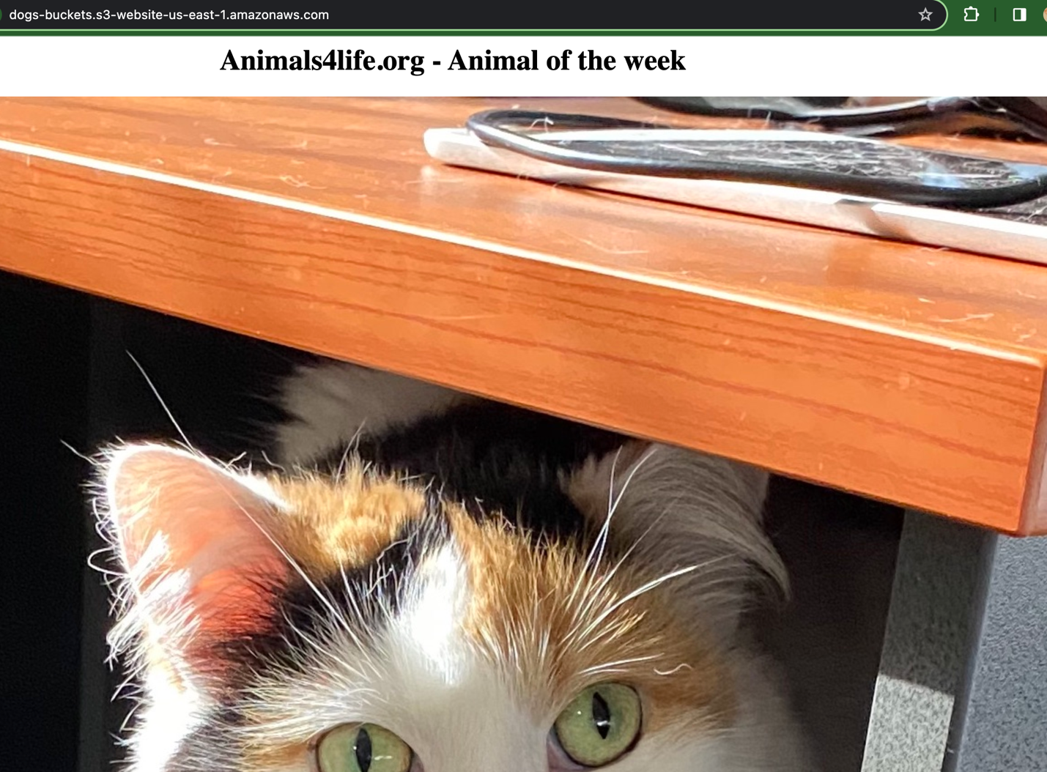

Delete version of object will be deleted permanently

1. Select version ---🡪 delete

Now the version is permenantly deleted and last version of image is served.

